ModusCloud Portal Documentation

V1.1

Last Updated: 02-25-20

This document contains instructions on how to use the ModusCloud spam portal. ModusCloud runs in the background, protecting your email from spam & malware. You will receive a "Quarantine Digest" email from ModusCloud regularly, detailing the emails it has blocked from your inbox.

## Access the ModusCloud Portal

To access your email log on ModusCloud, visit this URL:

<https://moduscloud.cloud-protect.net>

Enter your full email address in the Username field. Enter your email password in the Password field (unless your IT Department assigned a different password for ModusCloud only).

You should see the Email Log screen. Screenshot given as an example.

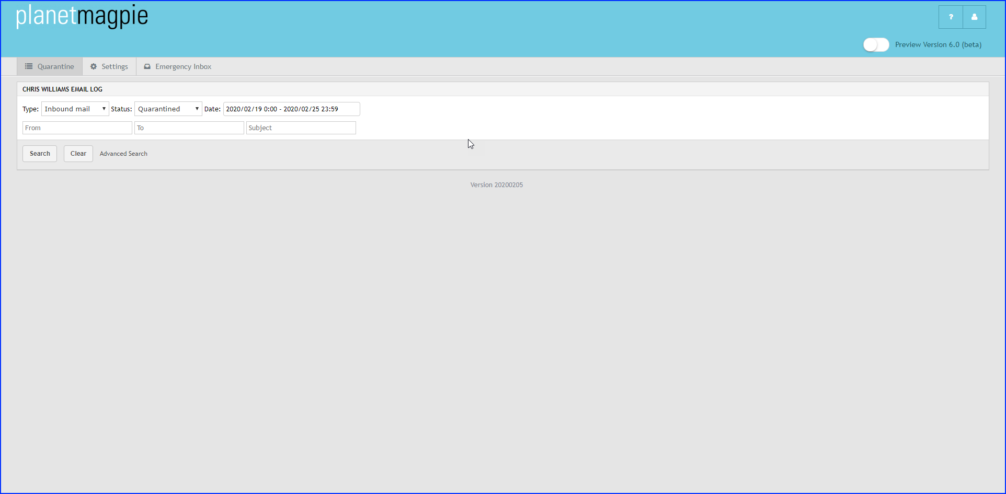

## Releasing a Message Caught in Quarantine

**FROM THE QUARANTINE DIGEST:**

1. Open the Quarantine Digest email showing the quarantined message.
2. To the message's right, click the "Release & Approve" link.

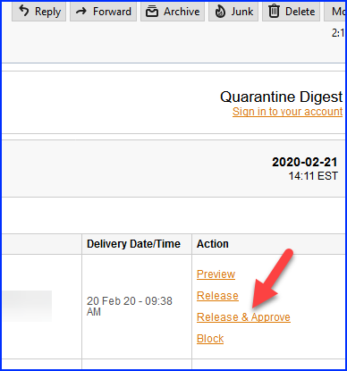

**FROM THE MODUSCLOUD PORTAL:**

1. Log into the ModusCloud portal.
2. You should see the Quarantine window. If not, click the Quarantine tab.
3. Set the Type to "Inbound Mail" if not already set.
4. Set the Status to "Quarantined."
5. Locate the quarantined message in the list.
   1. If you don't see it, set the Status to "Any" and look again.
6. Click the message's checkbox to select it.
7. Click the "Actions" menu.
8. Select "Release and Approve" from the actions list.

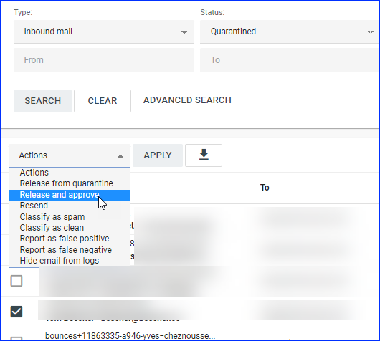

## Whitelisting/Blacklisting Email Addresses

If you receive email from certain parties whose messages continually appear in Quarantine, you can "whitelist" their email address in ModusCloud. This tells ModusCloud to let their messages through.

To add a sender email to the Safe Senders list:

1. Log into the ModusCloud portal.
2. Click Settings.
3. Click the "Sender Lists" tab.
4. Enter the email address in the "Safe Sender List" block. One email address per line.
5. Click Save button.

If you receive email from a known threat (cybercriminal, spammer), you can add their email address to ModusCloud's Blocked Sender list. This tells ModusCloud to quarantine all of their messages, so you don't see them.

To add a sender email to Blocked Senders list:

1. Log into the ModusCloud portal.
2. Click Settings.
3. Click the "Sender Lists" tab.
4. Enter the email address in the "Blocked Sender List" block. One email address per line.
5. Click the **Save** button.

## Reporting a Legitimate Message Marked Suspicious as OK (False Positive)

1. Log into the ModusCloud portal.
2. You should see the Quarantine window. If not, click the Quarantine tab.
3. In the Status dropdown, make sure "Quarantined" displays.
4. Click the **Search** button.
5. Locate the message in the results list.
6. Click the message's detail/view button.
7. Click the **Report as False Positive** button.
8. Fill out the information on the next page.
9. Click **Submit**.

## Marking a Message that Appeared in Your Inbox as Spam (False Negative)

1. Log into the ModusCloud portal.
2. You should see the Quarantine window. If not, click the Quarantine tab.
3. In the Status dropdown, click "Any."

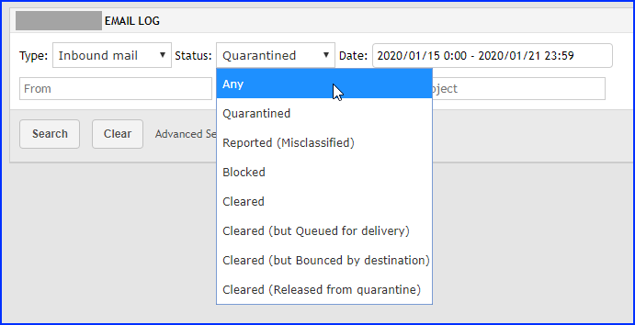

1. Click the **Search** button.
2. Locate the spam message in the results list.
3. Click the message's detail/view button.
4. Click the **Report as False Negative** button.
5. Fill out the information on the next page.
6. Click **Submit**.

## Use the Emergency Inbox

With the Emergency Inbox, you can access email through a webmail client, even if your mail server's down. (Not recommended for everyday use.)

To access the Emergency Inbox:

1. Log into the ModusCloud portal.
2. Click the Emergency Inbox tab.
3. A new window will open, displaying your emails.